**5.5 Guided Exercise: Encrypting a Folder Using EFS**

|  |  |
| --- | --- |
| **Resources** | |
| Files | None |
| Machines | Windows 10 |

In this exercise you will encrypt a folder along with its contents.

Login to Windows 10 and open File Explorer. Once File Explorer opens click on the Documents folder from the Quick Access menu on the left.

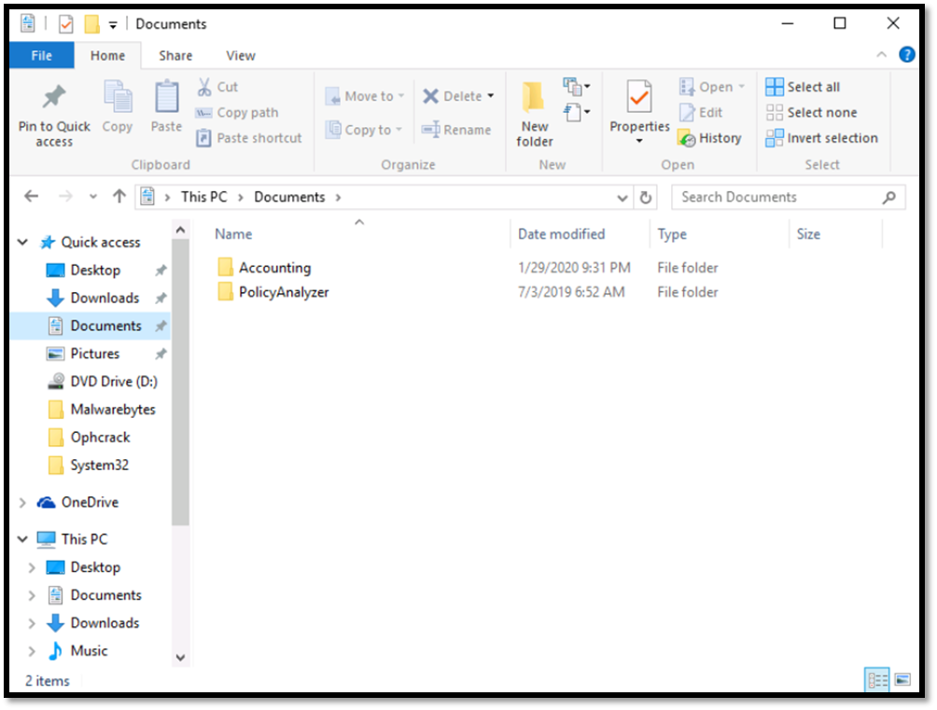

Within the Documents folder a subfolder exist with the name Accounting. Within the Accounting folder there are 3 files which are considered sensitive.

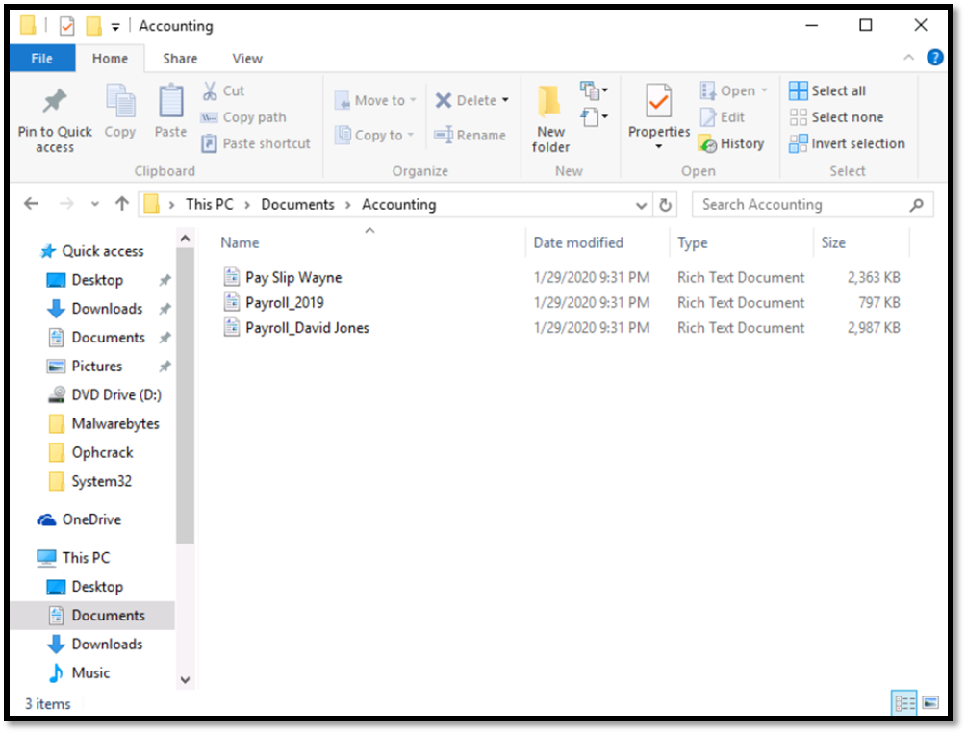

Right click on the Accounting folder and select Properties. On the Accounting Properties window, in the General tab click on Advanced.

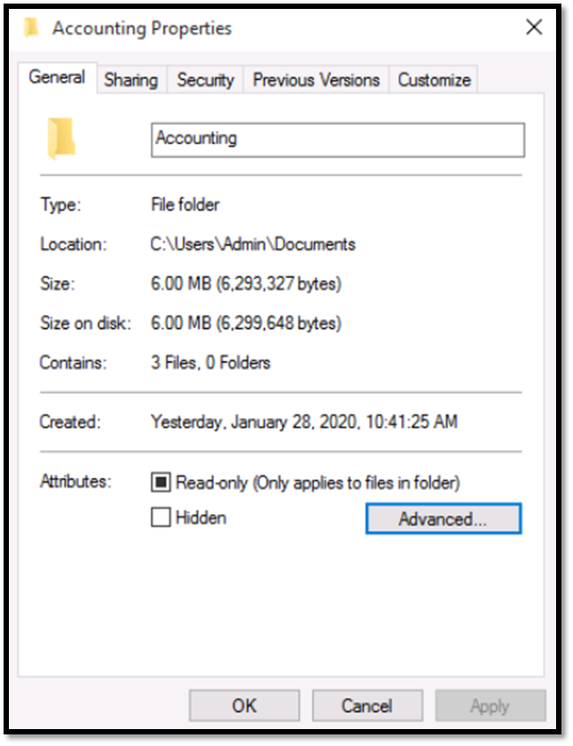

On the Advanced Attributes window click the option “Encrypt contents to secure data”. Then click OK and then Apply.

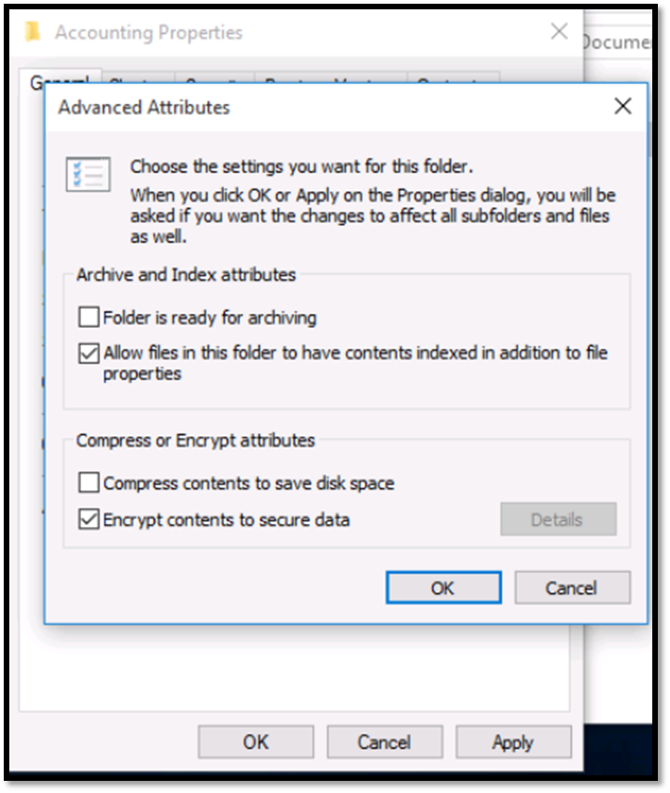

Once you click Apply a new window will open asking you to confirm the attribute changes. Select the option “Apply changes to this folder, subfolders and files” and click OK.  Click again OK to close the folder properties.

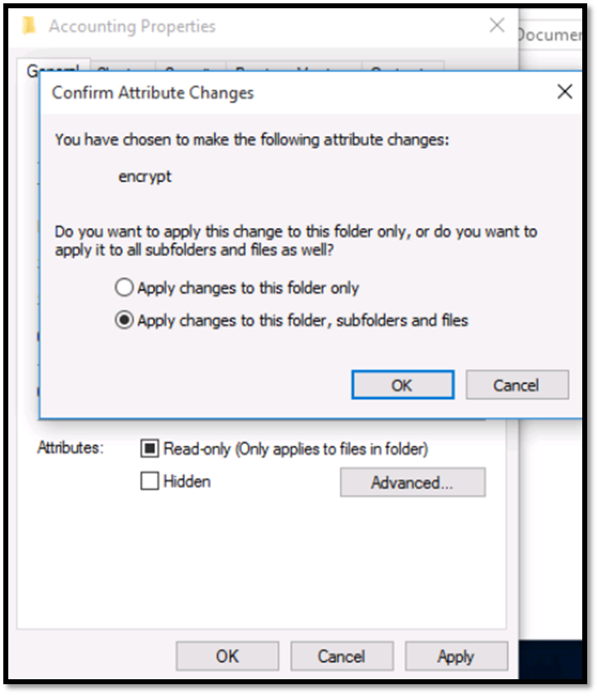

You will notice then that the Accounting folder has now the green color.

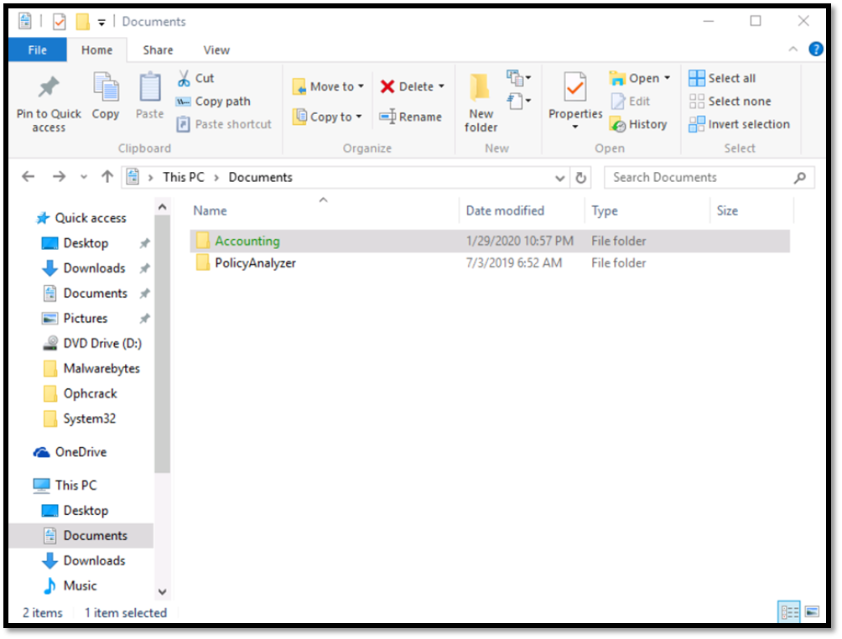  
Now that EFS is enabled a small icon exists in the taskbar which is the EFS key backup notice. It is always a good idea to backup the file encryption certificate and key. Click on the EFS icon in the taskbar and on the Window Encrypting File System select Back up now.

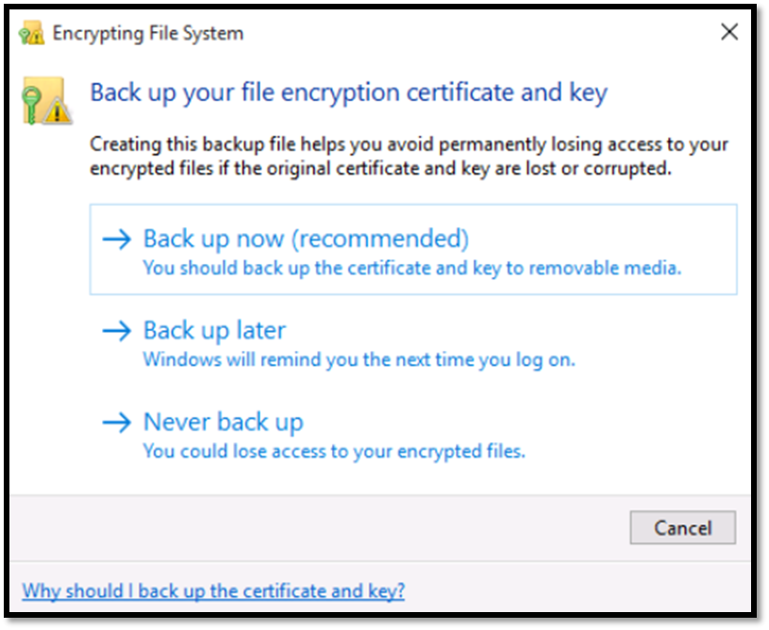

On the Certificate Export Wizard window click Next

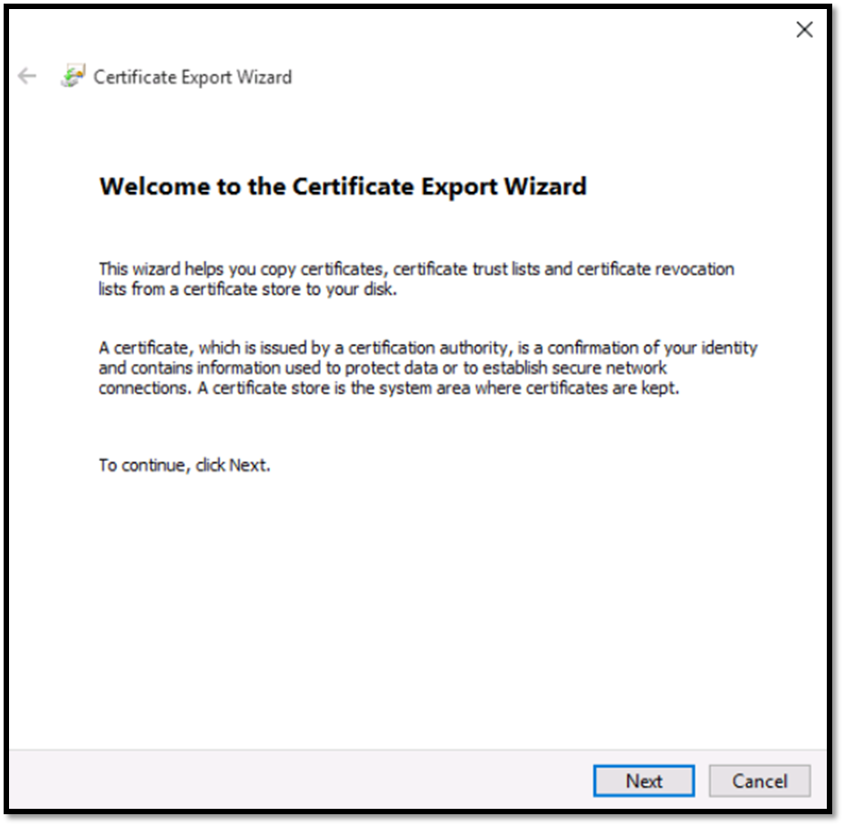

Ensure that the options Personal Information Exchange – PKCS, Include all certificates in the certification path if possible and Enable certificate privacy are checked.  Then click Next.

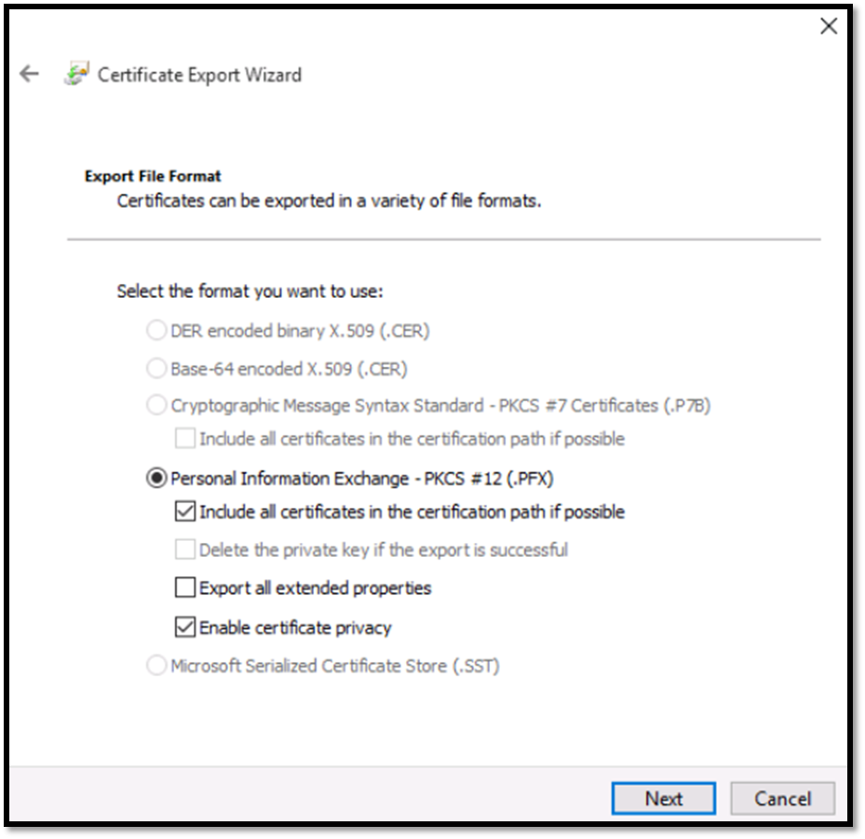

Check the box next to password and enter a password. For password use P@ssw0rd123! and click Next.

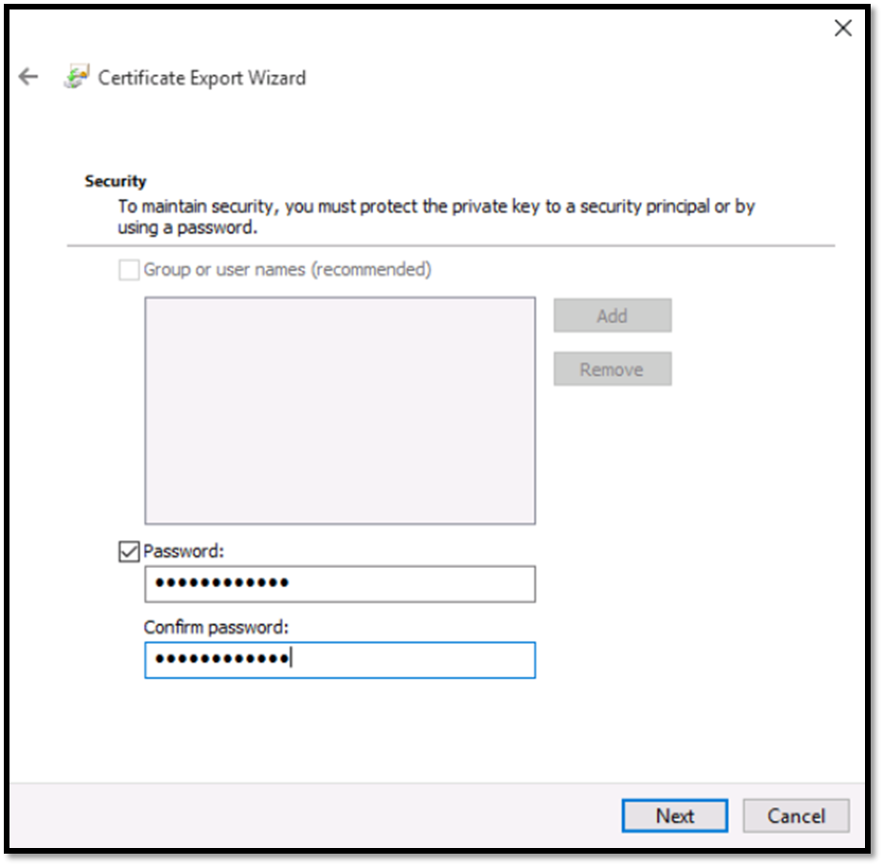

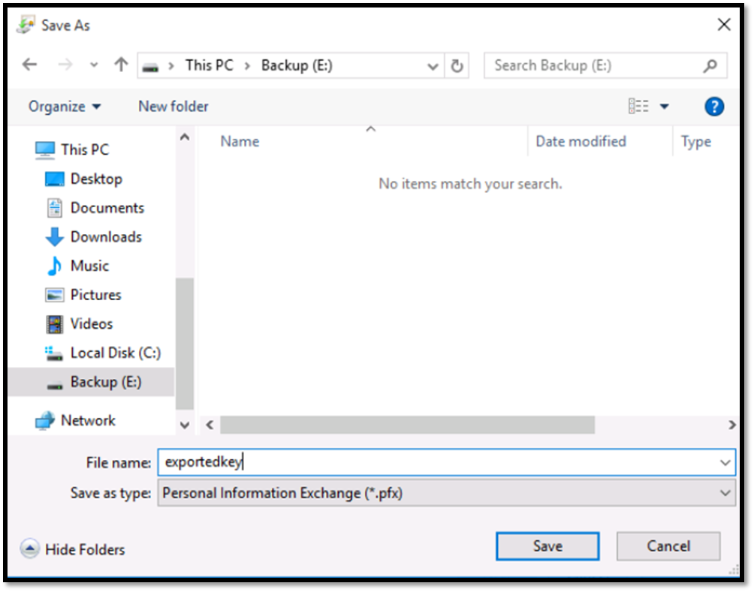Then click browse to select a location and a filename where the key should be saved. Select the Backup drive and for filename use exportedkey.

Click Save and then Next. On the next window simply review the File Name, File Format and other information of the certificate export. Then click Finish.

